Untitled

#### The analysis include exploratoray data analysis and an ordinal logistic regression model.

require("RCurl")

## Loading required package: RCurl

## Loading required package: bitops

### Load the data

#Raw dataset  
newdata1<-getURL("https://raw.githubusercontent.com/watex95/R-FOR-DATA-SCIENCE/master/DATASETS/Gvault_survey_raw.csv")  
df1<-read.csv(text=newdata1)

### EXPLORATORY DATA ANALYSIS

Load packages

require("plotrix")

## Loading required package: plotrix

#### Lets explore the frequency of single choice questions

How frequently do you use GVault QDMS?

table(df1$freq_use)

##   
## At least once a month At least once a week Daily   
## 51 144 245   
## Less than once a month   
## 35

barplot(table(df1$freq_use),ylab = "responses",col = "light green",  
 ,srt=45,las=2,yaxt='n',cex.names = 0.65,cex.lab=0.65)

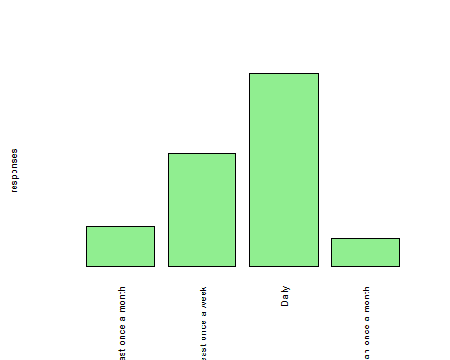

What is your role within GVault QDMS?

table(df1$role)

##   
## Consumer - Read Only Document Control Group Member   
## 153 16   
## Document Steward for a functional area Not Sure   
## 16 18   
## Owner / Author Reviewer / Approver   
## 142 130

barplot(table(df1$role),ylab = "responses",col = "light green",  
 srt=45,las=2,yaxt='n',cex.names = 0.65,cex.lab=0.65)

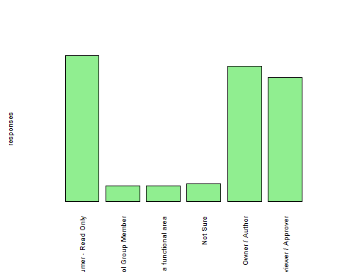

How would you describe the effectiveness of training you received?

table(df1$training_effectiveness)

##   
## Effective I did not take training Not effective enough   
## 291 29 72   
## Very effective   
## 83

barplot(table(df1$training_effectiveness),ylab = "responses",col = "light green",srt=45,las=2,yaxt='n',cex.names = 0.65,cex.lab=0.65)

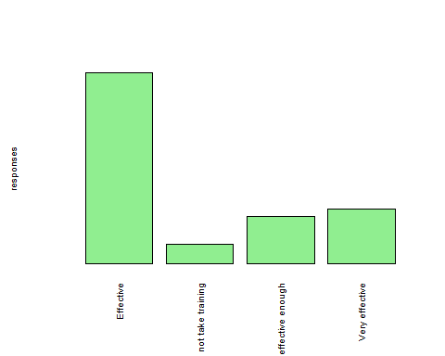

Are you able to complete work in the system without ‘help’ or ‘intervention’?

require(plotrix)  
mytable=table(df1$complete_without_help)  
lbls <- paste(names(mytable), "\n", mytable, sep="")  
pie3D(mytable, labels = lbls,explode=0.3)

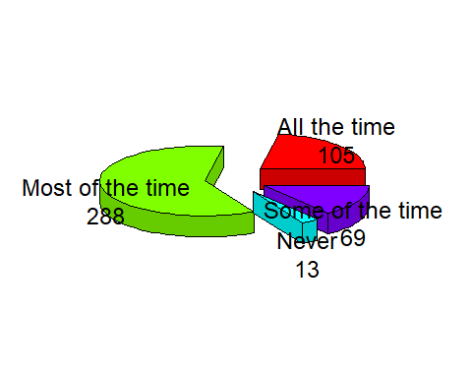

Do you find it easy to search for and access documents in GVault QDMS?

mytable=table(df1$easy_access_documents)  
lbls <- paste(names(mytable), "\n", mytable, sep="")  
pie3D(mytable, labels = lbls,explode=0.3)

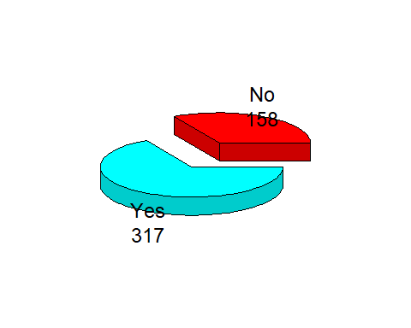

How satisfied are you with the overall experience of GVault QDMS?

mytable=table(df1$satisfaction)  
lbls <- paste(names(mytable), "\n", mytable, sep="")  
pie3D(mytable, labels = lbls,explode=0.3)

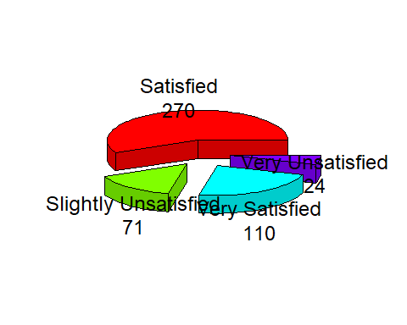

How would you describe your efficiency with GVault as compared to GDocs?

table(df1$Gvault_efficiency)

##   
## Decreased Increased   
## 18 75 270   
## No noticeable difference   
## 112

barplot(table(df1$Gvault_efficiency),ylab = "responses",col = "light green",srt=45,las=2,yaxt='n',cex.names = 0.65,cex.lab=0.65)

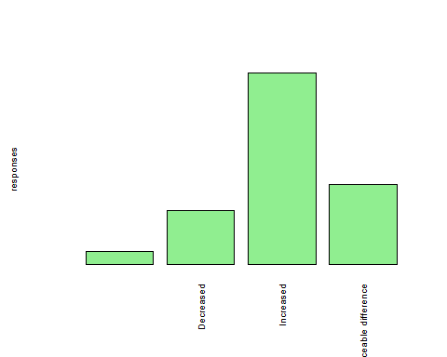

Do you find GVault has improved features and functionality compared to GDocs?

table(df1$Gvault_improved)

##   
## No Yes   
## 28 81 366

barplot(table(df1$Gvault_improved),ylab="responses",  
 col="light green",las=2, yaxt='n',cex.names = 0.65,cex.lab=0.65)

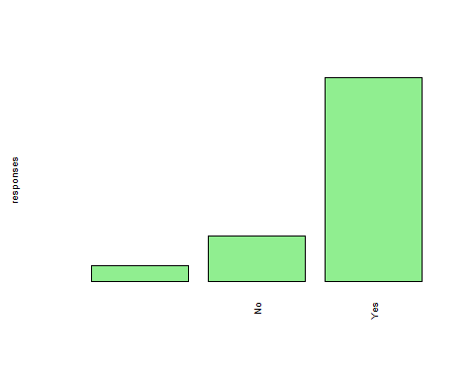

### Demographics analysis

What is your functional area?

table(df1$functional_area)

##   
##   
## 6   
## Commercial   
## 12   
## Facilities and Operations   
## 13   
## Finance   
## 1   
## Information Technology (IT)   
## 70   
## Other (please specify)   
## 37   
## Pharmaceutical Development and Manufacturing (PDM)   
## 217   
## Research and Development (R&D)   
## 119

barplot(table(df1$functional_area),ylab = "responses",col = "light green",srt=45,las=2,yaxt='n',cex.names = 0.65,cex.lab=0.65)

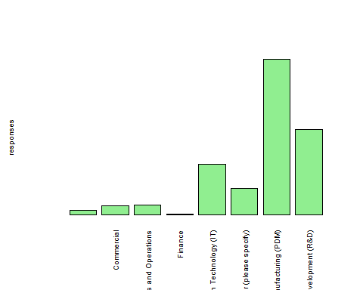

What is your office location?

table(df1$office_location)

##   
## Alberta Cambridge   
## 6 39 15   
## Cork/Dublin Foster City Oceanside   
## 25 244 22   
## Other (please specify) San Dimas/La Verne Seattle   
## 70 34 11   
## Stockley Park   
## 9

barplot(table(df1$office_location),ylab = "responses",col = "light green",srt=45,las=2,yaxt='n',cex.names = 0.65,cex.lab=0.65)

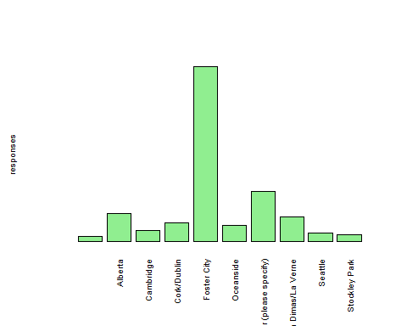

What is your Job Level?

table(df1$job_level)

##   
## Director Executive Leadership   
## 6 72 4   
## Individual Contributor Manager / Group Leader Other (please specify)   
## 208 133 52

barplot(table(df1$job_level),ylab = "responses",col = "light green",  
 srt=45,las=2,yaxt='n',cex.names = 0.65,cex.lab=0.65)

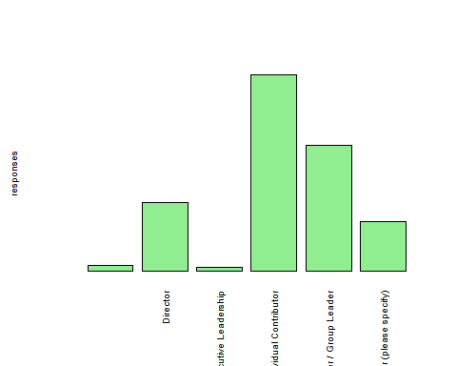

How long have you worked at Gilead?

table(df1$time_worked_Glead)

##   
## >7 Years 1 to 2 years 3-4 years   
## 6 123 73 128   
## 5-7 years Less than a year   
## 84 61

barplot(table(df1$time_worked_Glead),ylab = "responses",col = "light green",srt=45,las=2,yaxt='n',cex.names = 0.65,cex.lab=0.65)

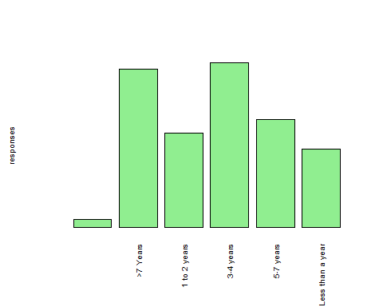

### Ordinal Logistic Regression (OLR)

##### Load the Libraries

require(foreign)

## Loading required package: foreign

require(ggplot2)

## Loading required package: ggplot2

require(MASS)

## Loading required package: MASS

require(Hmisc)

## Loading required package: Hmisc

## Loading required package: lattice

## Loading required package: survival

## Loading required package: Formula

##   
## Attaching package: 'Hmisc'

## The following objects are masked from 'package:base':  
##   
## format.pval, units

require(reshape2)

## Loading required package: reshape2

For building this model, we will be using the polr command to estimate an ordered logistic regression. Then, we’ll specify Hess=TRUE to let the model output show the observed information matrix from optimization which is used to get standard errors.

m<-polr(df1$satisfaction ~ df1$freq_use + df1$role  
 +df1$training_instructor_led + df1$training_web_based  
 + df1$training_read+ df1$no_training+df1$training_effectiveness  
 + df1$support_Gnet + df1$support_inapplication  
 +df1$support_ref_doc + df1$support_SOP + df1$support_contacted  
 +df1$support_IT + df1$complete_without_help  
 +df1$easy_access_documents + df1$Gvault_efficiency  
 +df1$Gvault_improved,data=df1,Hess=TRUE)  
summary(m)

## Call:  
## polr(formula = df1$satisfaction ~ df1$freq_use + df1$role + df1$training_instructor_led +   
## df1$training_web_based + df1$training_read + df1$no_training +   
## df1$training_effectiveness + df1$support_Gnet + df1$support_inapplication +   
## df1$support_ref_doc + df1$support_SOP + df1$support_contacted +   
## df1$support_IT + df1$complete_without_help + df1$easy_access_documents +   
## df1$Gvault_efficiency + df1$Gvault_improved, data = df1,   
## Hess = TRUE)  
##   
## Coefficients:  
## Value  
## df1$freq_useAt least once a week -0.061256  
## df1$freq_useDaily -0.225149  
## df1$freq_useLess than once a month -0.298138  
## df1$roleDocument Control Group Member -0.035346  
## df1$roleDocument Steward for a functional area 0.839250  
## df1$roleNot Sure -0.710795  
## df1$roleOwner / Author 0.232541  
## df1$roleReviewer / Approver 0.149034  
## df1$training_instructor_ledInstructor Led -0.014088  
## df1$training_web_basedWeb/Computer Based -0.201767  
## df1$training_readRead & Understood of Procedural Document(s) 0.233305  
## df1$no_trainingI did not take training -2.164934  
## df1$training_effectivenessI did not take training 2.662338  
## df1$training_effectivenessNot effective enough 0.418935  
## df1$training_effectivenessVery effective 1.469944  
## df1$support_GnetGNet 0.007038  
## df1$support_inapplicationIn-Application (GVault) 0.672101  
## df1$support_ref_docReference Document (User Manual, Reference Guide, Training Material, etc) 0.349751  
## df1$support_SOPSOPs and Work Instructions 0.112311  
## df1$support_contactedContacted my Document Control or Training Group -0.224774  
## df1$support_ITIT Support / SPARC 0.062084  
## df1$complete_without_helpMost of the time -0.900815  
## df1$complete_without_helpNever 0.499156  
## df1$complete_without_helpSome of the time -0.261270  
## df1$easy_access_documentsYes -0.162641  
## df1$Gvault_efficiencyDecreased 0.925684  
## df1$Gvault_efficiencyIncreased 0.813776  
## df1$Gvault_efficiencyNo noticeable difference 0.107436  
## df1$Gvault_improvedNo 1.889843  
## df1$Gvault_improvedYes 0.539834  
## Std. Error  
## df1$freq_useAt least once a week 0.3640  
## df1$freq_useDaily 0.3642  
## df1$freq_useLess than once a month 0.5118  
## df1$roleDocument Control Group Member 0.5846  
## df1$roleDocument Steward for a functional area 0.5561  
## df1$roleNot Sure 0.6216  
## df1$roleOwner / Author 0.2884  
## df1$roleReviewer / Approver 0.2782  
## df1$training_instructor_ledInstructor Led 0.2450  
## df1$training_web_basedWeb/Computer Based 0.2269  
## df1$training_readRead & Understood of Procedural Document(s) 0.2339  
## df1$no_trainingI did not take training 1.3209  
## df1$training_effectivenessI did not take training 1.3396  
## df1$training_effectivenessNot effective enough 0.2972  
## df1$training_effectivenessVery effective 0.2688  
## df1$support_GnetGNet 0.2210  
## df1$support_inapplicationIn-Application (GVault) 0.2336  
## df1$support_ref_docReference Document (User Manual, Reference Guide, Training Material, etc) 0.2145  
## df1$support_SOPSOPs and Work Instructions 0.2152  
## df1$support_contactedContacted my Document Control or Training Group 0.2209  
## df1$support_ITIT Support / SPARC 0.3173  
## df1$complete_without_helpMost of the time 0.2542  
## df1$complete_without_helpNever 0.6184  
## df1$complete_without_helpSome of the time 0.3708  
## df1$easy_access_documentsYes 0.2574  
## df1$Gvault_efficiencyDecreased 0.8537  
## df1$Gvault_efficiencyIncreased 0.8234  
## df1$Gvault_efficiencyNo noticeable difference 0.8297  
## df1$Gvault_improvedNo 0.6701  
## df1$Gvault_improvedYes 0.6258  
## t value  
## df1$freq_useAt least once a week -0.16828  
## df1$freq_useDaily -0.61814  
## df1$freq_useLess than once a month -0.58252  
## df1$roleDocument Control Group Member -0.06046  
## df1$roleDocument Steward for a functional area 1.50921  
## df1$roleNot Sure -1.14345  
## df1$roleOwner / Author 0.80632  
## df1$roleReviewer / Approver 0.53578  
## df1$training_instructor_ledInstructor Led -0.05751  
## df1$training_web_basedWeb/Computer Based -0.88939  
## df1$training_readRead & Understood of Procedural Document(s) 0.99730  
## df1$no_trainingI did not take training -1.63898  
## df1$training_effectivenessI did not take training 1.98735  
## df1$training_effectivenessNot effective enough 1.40961  
## df1$training_effectivenessVery effective 5.46838  
## df1$support_GnetGNet 0.03184  
## df1$support_inapplicationIn-Application (GVault) 2.87713  
## df1$support_ref_docReference Document (User Manual, Reference Guide, Training Material, etc) 1.63043  
## df1$support_SOPSOPs and Work Instructions 0.52185  
## df1$support_contactedContacted my Document Control or Training Group -1.01772  
## df1$support_ITIT Support / SPARC 0.19564  
## df1$complete_without_helpMost of the time -3.54343  
## df1$complete_without_helpNever 0.80717  
## df1$complete_without_helpSome of the time -0.70457  
## df1$easy_access_documentsYes -0.63187  
## df1$Gvault_efficiencyDecreased 1.08428  
## df1$Gvault_efficiencyIncreased 0.98825  
## df1$Gvault_efficiencyNo noticeable difference 0.12949  
## df1$Gvault_improvedNo 2.82023  
## df1$Gvault_improvedYes 0.86269  
##   
## Intercepts:  
## Value Std. Error t value  
## Satisfied|Slightly Unsatisfied 1.6519 0.7826 2.1109  
## Slightly Unsatisfied|Very Satisfied 2.4814 0.7885 3.1472  
## Very Satisfied|Very Unsatisfied 4.7798 0.8193 5.8342  
##   
## Residual Deviance: 914.5326   
## AIC: 980.5326

We see the usual regression output coefficient table including the value of each coefficient, standard errors, t values, estimates for the two intercepts, residual deviance and AIC. AIC is the information criteria. Lesser the better.

Now we’ll calculate some essential metrics such as p-Value, CI, Odds ratio. The output displayed next are values: log odds(coefficients of estimation), t values are the t-distribution test statistic values, and finally the p-values are the probability of error.

ctable <- coef(summary(m))  
p <- pnorm(abs(ctable[, "t value"]), lower.tail = FALSE) * 2  
ctable <- cbind(ctable, "p value" = p)  
ctable

## Value  
## df1$freq_useAt least once a week -0.061255520  
## df1$freq_useDaily -0.225148789  
## df1$freq_useLess than once a month -0.298137738  
## df1$roleDocument Control Group Member -0.035346366  
## df1$roleDocument Steward for a functional area 0.839250212  
## df1$roleNot Sure -0.710794769  
## df1$roleOwner / Author 0.232540770  
## df1$roleReviewer / Approver 0.149033738  
## df1$training_instructor_ledInstructor Led -0.014088132  
## df1$training_web_basedWeb/Computer Based -0.201766655  
## df1$training_readRead & Understood of Procedural Document(s) 0.233305064  
## df1$no_trainingI did not take training -2.164933941  
## df1$training_effectivenessI did not take training 2.662337561  
## df1$training_effectivenessNot effective enough 0.418934925  
## df1$training_effectivenessVery effective 1.469944319  
## df1$support_GnetGNet 0.007037608  
## df1$support_inapplicationIn-Application (GVault) 0.672101137  
## df1$support_ref_docReference Document (User Manual, Reference Guide, Training Material, etc) 0.349751351  
## df1$support_SOPSOPs and Work Instructions 0.112310847  
## df1$support_contactedContacted my Document Control or Training Group -0.224773958  
## df1$support_ITIT Support / SPARC 0.062083893  
## df1$complete_without_helpMost of the time -0.900814906  
## df1$complete_without_helpNever 0.499156305  
## df1$complete_without_helpSome of the time -0.261270473  
## df1$easy_access_documentsYes -0.162640886  
## df1$Gvault_efficiencyDecreased 0.925683533  
## df1$Gvault_efficiencyIncreased 0.813775704  
## df1$Gvault_efficiencyNo noticeable difference 0.107435707  
## df1$Gvault_improvedNo 1.889843138  
## df1$Gvault_improvedYes 0.539833742  
## Satisfied|Slightly Unsatisfied 1.651903387  
## Slightly Unsatisfied|Very Satisfied 2.481428832  
## Very Satisfied|Very Unsatisfied 4.779807594  
## Std. Error  
## df1$freq_useAt least once a week 0.3640076  
## df1$freq_useDaily 0.3642379  
## df1$freq_useLess than once a month 0.5118063  
## df1$roleDocument Control Group Member 0.5846309  
## df1$roleDocument Steward for a functional area 0.5560856  
## df1$roleNot Sure 0.6216254  
## df1$roleOwner / Author 0.2883987  
## df1$roleReviewer / Approver 0.2781638  
## df1$training_instructor_ledInstructor Led 0.2449576  
## df1$training_web_basedWeb/Computer Based 0.2268604  
## df1$training_readRead & Understood of Procedural Document(s) 0.2339372  
## df1$no_trainingI did not take training 1.3209057  
## df1$training_effectivenessI did not take training 1.3396388  
## df1$training_effectivenessNot effective enough 0.2971996  
## df1$training_effectivenessVery effective 0.2688082  
## df1$support_GnetGNet 0.2210034  
## df1$support_inapplicationIn-Application (GVault) 0.2336016  
## df1$support_ref_docReference Document (User Manual, Reference Guide, Training Material, etc) 0.2145142  
## df1$support_SOPSOPs and Work Instructions 0.2152168  
## df1$support_contactedContacted my Document Control or Training Group 0.2208596  
## df1$support_ITIT Support / SPARC 0.3173358  
## df1$complete_without_helpMost of the time 0.2542211  
## df1$complete_without_helpNever 0.6184067  
## df1$complete_without_helpSome of the time 0.3708206  
## df1$easy_access_documentsYes 0.2573965  
## df1$Gvault_efficiencyDecreased 0.8537290  
## df1$Gvault_efficiencyIncreased 0.8234482  
## df1$Gvault_efficiencyNo noticeable difference 0.8296784  
## df1$Gvault_improvedNo 0.6701029  
## df1$Gvault_improvedYes 0.6257589  
## Satisfied|Slightly Unsatisfied 0.7825531  
## Slightly Unsatisfied|Very Satisfied 0.7884581  
## Very Satisfied|Very Unsatisfied 0.8192696  
## t value  
## df1$freq_useAt least once a week -0.16828087  
## df1$freq_useDaily -0.61813665  
## df1$freq_useLess than once a month -0.58252067  
## df1$roleDocument Control Group Member -0.06045929  
## df1$roleDocument Steward for a functional area 1.50921053  
## df1$roleNot Sure -1.14344556  
## df1$roleOwner / Author 0.80631711  
## df1$roleReviewer / Approver 0.53577681  
## df1$training_instructor_ledInstructor Led -0.05751253  
## df1$training_web_basedWeb/Computer Based -0.88938675  
## df1$training_readRead & Understood of Procedural Document(s) 0.99729791  
## df1$no_trainingI did not take training -1.63897685  
## df1$training_effectivenessI did not take training 1.98735477  
## df1$training_effectivenessNot effective enough 1.40960810  
## df1$training_effectivenessVery effective 5.46837694  
## df1$support_GnetGNet 0.03184388  
## df1$support_inapplicationIn-Application (GVault) 2.87712521  
## df1$support_ref_docReference Document (User Manual, Reference Guide, Training Material, etc) 1.63043451  
## df1$support_SOPSOPs and Work Instructions 0.52184971  
## df1$support_contactedContacted my Document Control or Training Group -1.01772325  
## df1$support_ITIT Support / SPARC 0.19564098  
## df1$complete_without_helpMost of the time -3.54343092  
## df1$complete_without_helpNever 0.80716509  
## df1$complete_without_helpSome of the time -0.70457384  
## df1$easy_access_documentsYes -0.63186911  
## df1$Gvault_efficiencyDecreased 1.08428267  
## df1$Gvault_efficiencyIncreased 0.98825372  
## df1$Gvault_efficiencyNo noticeable difference 0.12949078  
## df1$Gvault_improvedNo 2.82022827  
## df1$Gvault_improvedYes 0.86268647  
## Satisfied|Slightly Unsatisfied 2.11091543  
## Slightly Unsatisfied|Very Satisfied 3.14719184  
## Very Satisfied|Very Unsatisfied 5.83423013  
## p value  
## df1$freq_useAt least once a week 8.663623e-01  
## df1$freq_useDaily 5.364853e-01  
## df1$freq_useLess than once a month 5.602160e-01  
## df1$roleDocument Control Group Member 9.517898e-01  
## df1$roleDocument Steward for a functional area 1.312450e-01  
## df1$roleNot Sure 2.528536e-01  
## df1$roleOwner / Author 4.200600e-01  
## df1$roleReviewer / Approver 5.921128e-01  
## df1$training_instructor_ledInstructor Led 9.541369e-01  
## df1$training_web_basedWeb/Computer Based 3.737953e-01  
## df1$training_readRead & Understood of Procedural Document(s) 3.186199e-01  
## df1$no_trainingI did not take training 1.012181e-01  
## df1$training_effectivenessI did not take training 4.688310e-02  
## df1$training_effectivenessNot effective enough 1.586554e-01  
## df1$training_effectivenessVery effective 4.541752e-08  
## df1$support_GnetGNet 9.745965e-01  
## df1$support_inapplicationIn-Application (GVault) 4.013163e-03  
## df1$support_ref_docReference Document (User Manual, Reference Guide, Training Material, etc) 1.030097e-01  
## df1$support_SOPSOPs and Work Instructions 6.017750e-01  
## df1$support_contactedContacted my Document Control or Training Group 3.088095e-01  
## df1$support_ITIT Support / SPARC 8.448912e-01  
## df1$complete_without_helpMost of the time 3.949568e-04  
## df1$complete_without_helpNever 4.195714e-01  
## df1$complete_without_helpSome of the time 4.810755e-01  
## df1$easy_access_documentsYes 5.274724e-01  
## df1$Gvault_efficiencyDecreased 2.782395e-01  
## df1$Gvault_efficiencyIncreased 3.230284e-01  
## df1$Gvault_efficiencyNo noticeable difference 8.969693e-01  
## df1$Gvault_improvedNo 4.798950e-03  
## df1$Gvault_improvedYes 3.883099e-01  
## Satisfied|Slightly Unsatisfied 3.477958e-02  
## Slightly Unsatisfied|Very Satisfied 1.648468e-03  
## Very Satisfied|Very Unsatisfied 5.403950e-09

#### Odds Ratios and their Confidence Intervals

ci <- confint(m)

## Waiting for profiling to be done...

exp(cbind(OR = coef(m), ci))

## OR  
## df1$freq_useAt least once a week 0.9405829  
## df1$freq_useDaily 0.7983974  
## df1$freq_useLess than once a month 0.7421991  
## df1$roleDocument Control Group Member 0.9652710  
## df1$roleDocument Steward for a functional area 2.3146308  
## df1$roleNot Sure 0.4912536  
## df1$roleOwner / Author 1.2618019  
## df1$roleReviewer / Approver 1.1607121  
## df1$training_instructor_ledInstructor Led 0.9860106  
## df1$training_web_basedWeb/Computer Based 0.8172856  
## df1$training_readRead & Understood of Procedural Document(s) 1.2627666  
## df1$no_trainingI did not take training 0.1147575  
## df1$training_effectivenessI did not take training 14.3297466  
## df1$training_effectivenessNot effective enough 1.5203414  
## df1$training_effectivenessVery effective 4.3489930  
## df1$support_GnetGNet 1.0070624  
## df1$support_inapplicationIn-Application (GVault) 1.9583478  
## df1$support_ref_docReference Document (User Manual, Reference Guide, Training Material, etc) 1.4187147  
## df1$support_SOPSOPs and Work Instructions 1.1188606  
## df1$support_contactedContacted my Document Control or Training Group 0.7986967  
## df1$support_ITIT Support / SPARC 1.0640516  
## df1$complete_without_helpMost of the time 0.4062385  
## df1$complete_without_helpNever 1.6473308  
## df1$complete_without_helpSome of the time 0.7700726  
## df1$easy_access_documentsYes 0.8498963  
## df1$Gvault_efficiencyDecreased 2.5235926  
## df1$Gvault_efficiencyIncreased 2.2564115  
## df1$Gvault_efficiencyNo noticeable difference 1.1134193  
## df1$Gvault_improvedNo 6.6183304  
## df1$Gvault_improvedYes 1.7157216  
## 2.5 %  
## df1$freq_useAt least once a week 0.463984624  
## df1$freq_useDaily 0.393674401  
## df1$freq_useLess than once a month 0.266853560  
## df1$roleDocument Control Group Member 0.298130157  
## df1$roleDocument Steward for a functional area 0.756901241  
## df1$roleNot Sure 0.131970798  
## df1$roleOwner / Author 0.717716313  
## df1$roleReviewer / Approver 0.673176065  
## df1$training_instructor_ledInstructor Led 0.610563800  
## df1$training_web_basedWeb/Computer Based 0.524022291  
## df1$training_readRead & Understood of Procedural Document(s) 0.800739629  
## df1$no_trainingI did not take training 0.004596766  
## df1$training_effectivenessI did not take training 1.250406179  
## df1$training_effectivenessNot effective enough 0.843980236  
## df1$training_effectivenessVery effective 2.572731017  
## df1$support_GnetGNet 0.650983679  
## df1$support_inapplicationIn-Application (GVault) 1.238240827  
## df1$support_ref_docReference Document (User Manual, Reference Guide, Training Material, etc) 0.932364218  
## df1$support_SOPSOPs and Work Instructions 0.733004716  
## df1$support_contactedContacted my Document Control or Training Group 0.517337265  
## df1$support_ITIT Support / SPARC 0.564939050  
## df1$complete_without_helpMost of the time 0.246551259  
## df1$complete_without_helpNever 0.473766898  
## df1$complete_without_helpSome of the time 0.370922492  
## df1$easy_access_documentsYes 0.513532685  
## df1$Gvault_efficiencyDecreased 0.479579095  
## df1$Gvault_efficiencyIncreased 0.456763606  
## df1$Gvault_efficiencyNo noticeable difference 0.221095979  
## df1$Gvault_improvedNo 1.896190043  
## df1$Gvault_improvedYes 0.537459748  
## 97.5 %  
## df1$freq_useAt least once a week 1.9416099  
## df1$freq_useDaily 1.6491686  
## df1$freq_useLess than once a month 2.0030414  
## df1$roleDocument Control Group Member 2.9884884  
## df1$roleDocument Steward for a functional area 6.8122375  
## df1$roleNot Sure 1.5668129  
## df1$roleOwner / Author 2.2266164  
## df1$roleReviewer / Approver 2.0062932  
## df1$training_instructor_ledInstructor Led 1.5969506  
## df1$training_web_basedWeb/Computer Based 1.2766539  
## df1$training_readRead & Understood of Procedural Document(s) 2.0058319  
## df1$no_trainingI did not take training 1.2460146  
## df1$training_effectivenessI did not take training 363.9223923  
## df1$training_effectivenessNot effective enough 2.7125669  
## df1$training_effectivenessVery effective 7.3915420  
## df1$support_GnetGNet 1.5498643  
## df1$support_inapplicationIn-Application (GVault) 3.0976786  
## df1$support_ref_docReference Document (User Manual, Reference Guide, Training Material, etc) 2.1638272  
## df1$support_SOPSOPs and Work Instructions 1.7057883  
## df1$support_contactedContacted my Document Control or Training Group 1.2308936  
## df1$support_ITIT Support / SPARC 1.9673261  
## df1$complete_without_helpMost of the time 0.6688372  
## df1$complete_without_helpNever 5.4780282  
## df1$complete_without_helpSome of the time 1.5909998  
## df1$easy_access_documentsYes 1.4113909  
## df1$Gvault_efficiencyDecreased 14.4853373  
## df1$Gvault_efficiencyIncreased 12.3340562  
## df1$Gvault_efficiencyNo noticeable difference 6.1067697  
## df1$Gvault_improvedNo 27.2439790  
## df1$Gvault_improvedYes 6.5299143

#### Interpretation at a glance: The effect of one predictor on the odds/likelihood of satisfaction

When Gvault is used atleast once a week versus atleast once a month, the odds of satisfaction being very satisfied are 0.9 greater than the odds of either “satisfied” , “slightly unsatisfied” or “very unsatisfied” combined. NOTE: The reference level selected was “atleast once a month”

When the training is very effective versus effective training, the odds of a user being very satisfied are 4.38 greater than the odds of being either “satisfied” , “slightly unsatisfied” or “very unsatisfied” combined. NOTE: The reference level selected was “effective”

### Summary

Most of the predictor variables were not statistically significant in predicting the level of satisfaction with the overall experience of GVault QDMS. Training effectiveness (p-value=0.04688), Support for In application(p-value=0.00401), complete work without(p-value=0.000395) help,and whether Gvault improved features(p-value=0.0.00479) were the variables that significantly affected satisfaction of a user.